TAFE NSW Summer Football 2018 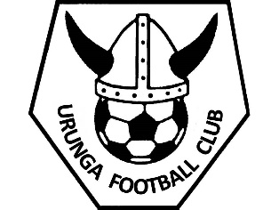
Senior – Men’s, Women’s or Social Mixed Team Nomination Form 2018

The 6-a-side competition will run on Thursday evenings at Urunga Recreation grounds. The competition will run from October 25th 2018 through to December 20th with a short break over the Christmas period. Games will recommence on January 24th 2019 and will finish February 21st.

As well as completing a team nomination form, ALL players will be required to register online as an individual. Access to online registration is via the Urunga Football Club website, www.urungafootball.com or www.playfootball.com.au

** No player can take the field unless they have registered their FFA online. Registration options are “Registered” for 2018 Winter Comp or “Unregistered” for 2018 Winter Comp
** Please refer to the 6-A-Side Competition rules on our website

Cost: $700 per team to be collected by the team manager.
Team registration money is to be deposited into the account below as a single team payment, with the TEAM NAME as the reference by 11th October:

Account Name: Urunga Football Club
BSB: 533 000
Account Number: 142485

Team Name: ___________________________ Preferred Division
Men’s A
Team Contact: ___________________________ Women’s A
Phone Number: ___________________________ Men’s B
Email Address: ____________________________ Women’s A
Social Mixed

Player Name | Date of Birth | FFA Number
1.
2.
3.
4.
5.
6.
7.
8.
9.
10.

Nomination forms must be completed and emailed to
Vanessa Hogan at vanessa@urungafootball.com
Any questions please contact:
UFC 6-A-Side Coordinator Michael McCormick on 0402 928 344 or Vanessa Hogan on 0412 649 649
LIKE and Share our Urunga 6 A Side Soccer and Urunga Football Club Facebook pages for updates

