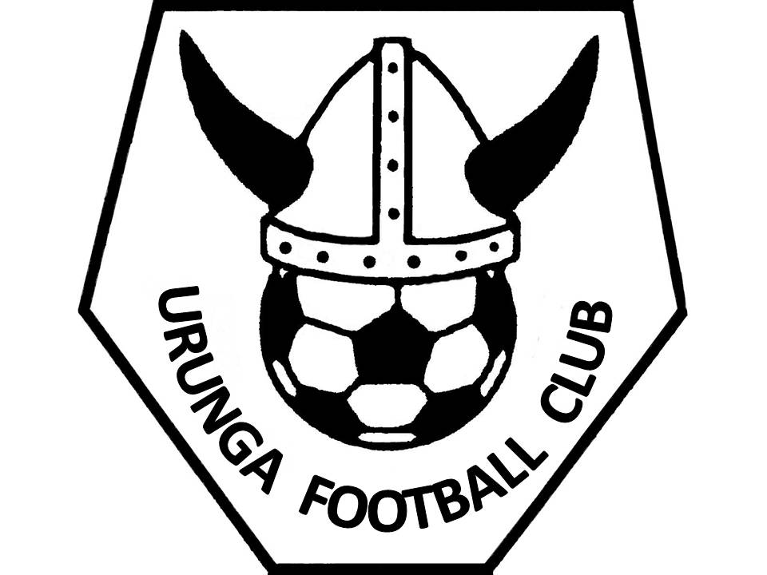

EXPRESSION OF INTERSET
COACHES AND MANAGERS
2017

MENS Premier and Reserve Grade
Women’s 1st and 2nd Division

Expression of Interest for the role of:
Coach or Manager or Assistant Coach

(Response to this EOI must be received before 29 December 2016)
Submit to Secretary, Urunga Football Club PO Box 173 URUNGA 2455 or
secretary@urungafootball.com

This form must be completed as a cover page to the Response.

I, (full name) _______________________________________________________________

Of (address)
_______________________________________________________________

D.O.B: _____________Ph: ________________ Mobile: __________________

Email: __________________________________________________________

I am seeking appointment as coach / manager / assistant coach (strike through non applicable roles) for the following team ______________________ and submit my application for consideration by UFC.

Acknowledgements

- I understand that the Club and its volunteers have responsibilities at law to protect the welfare of children and that a Working With Children Check is mandatory for all coaches, managers and committee persons. My WWCC or APP is shown below.

- I have read and understand the UFC Memorandum Of Understanding for Coaches and Managers.

- I have read & agree to abide by the Coaches Code of Ethics and Code/Role of Team Manager.

- I have read and commit to implement the FFA National Curriculum. (Refer http://www.a-league.com.au/site/_content/document/00001254-source.pdf)

- I understand that the UFC and North Coast Football is required to implement a complaint handling procedure in accordance with the principles of natural justice, in the event of an allegation against me. As such, I acknowledge that UFC and or NCF may impose penalty on me or rescind my appointment as coach or manager by resolution of the NCF and or the Committee.

- I agree to abide by the directives of the UFC Management Committee who will abide by the applicable Rules and Regulations and Codes of FFA and or NCF

- I submit my response in the attached format for evaluation by the Selection Committee

______________________ _________________
Applicant Signature Date

Working With Children Number or APP ______________________________

Working with Children Check (WWCC)
Since June 2013 people seeking to work or volunteer with children under 18 years in NSW have been required to have a Working With Children Check (WWCC). Employers, including sports clubs and associations, are also required to verify all WWCCs through an online system.
UFC must Identify, Notify, Register and Verify. We have identified that all coaches and committee require a WWCC. While there are a number of important exemptions from the WWCC requirement, including for volunteer parents or other close relatives of a child, UFC encourage all coaches to obtain a WWCC regardless of any exemption at law.
We must Notify all volunteers that they need to provide us with a WWCC number or their application (APP) number. This has been the case since 1 April 2015. We have registered our club online as an employer in child related work.
We must Verify the status of each WWC or APP number, keeping a record of each verification result. This is ongoing given the turn-over in volunteers in our club. These records must be retained by the club to be made available if we are audited by the Office of the Children’s Guardian. The WWCC is valid for five years but a clearance to work or volunteer with children can be changed as a result of new records or notifications. On line registration and verification is necessary to ensure records are up to date and changes to a WWCC status can be notified.
The Working With Children Check provides a unique number (the WWC number) to a person who has been cleared to work with children. The WWCC application process involves a national police check and a review of findings of workplace misconduct. The result is either a clearance to work with children for five years, or a bar against working with children. Barred applicants may not work or volunteer with children. If a person receives an interim bar, they must be immediately removed from their child-related position in the organisation. The WWCC clearance lasts for five years and is continuously monitored for any new relevant offences.
This information has been extracted from the following Fact Sheet prepared by the Office of the Children’s Guardian. For the full details go to
http://www.kidsguardian.nsw.gov.au/ArticleDocuments/184/ChildSafeSports_screen.pdf.aspx?Embed=Y
and for additional information go to
http://www.kidsguardian.nsw.gov.au/about-us

Memorandum of Understanding
UFC Coaches and Managers
1. Reporting and communication:
The UFC Senior Coaches and Managers report to the UFC Management Committee.
The Premier Division Coach has a leading role for coaching and managing staff and must attend Committee meetings as required by the Committee.
2. Term of position:
Coaches and Team Managers will be engaged as volunteers by UFC on a one year appointment.
3. Payment:
The Premier Division Coach (Mens) and First Division (Womens) coach will be paid a sum of money to be agreed by the Committee of Management being an amount to defray costs incurred.
No other position is entitled to any payment but may make claims for reimbursement of costs for approval by the Committee prior to expenditure.
4. Responsibilities - Men’s Premier Division Coach (Head Coach)
- Implement coaching programs and coach / manage in accordance with national curriculum, Coaches Code of Ethics and any local objectives directed or agreed by the Committee.
- Lead, prepare and deliver structured high performance training programs for the Men’s Premier Division.
- Integrate training and development programs with the Youth Grade squad/s in collaboration with the Youth Grade Coach/es.
- Participate in the selection process for Talented Player coaching program for junior age groups
- Provide direction to any underpinning talent development / emerging talent programs that are implemented by the Committee.
- Work collaboratively with the Team Manager
- Provide feedback to the Committee on initiatives and issues of concern.

6. Selection Criteria:- Coaches
Qualifications:
Essential
- Applicants must hold a current Senior Licence, or be committed to undertake a Senior Licence; and
- Applicants must be committed to uphold the FFA Coaches Code of Ethics
Desirable
- Preparedness to undertake FFA C License when available;
- Experience in coaching and/or managing a range of adult, youth and junior football players;
- Demonstrated understanding of the needs of football players;
- Demonstrated skills in administration and organisation including computer literacy;
- Knowledge and understanding of relevant sports science (specifically football conditioning) requirements and their application to football;
- Demonstrated high level of written and oral communication skills;
- Proven ability to work independently and as a member of a team;
- Demonstrated understanding of the structure of national and state sporting organisations including the role of Institutes/Academies of Sport within the FFA National Talented Player Pathway.
- Demonstrated knowledge of the FFA National Curriculum.

Selection Criteria:- Managers
Desirable Qualifications
- Experience in managing sports teams at youth and junior levels
- Demonstrated understanding of the Team Managers Roles
- Demonstrated understanding of the needs of football players;
- Demonstrated skills in administration and organisation including computer literacy;
- Good level of written and oral communication skills;
- Proven ability to work independently and as a member of a team;
- Understanding of the structure of football in NSW
- Demonstrated knowledge of the FFA National Curriculum.

FFA Coach’s Code of Ethics

This code is designed:
- To emphasise the elements of enjoyment and satisfaction to players and coaches involved in soccer (Football).
- To make adults including parents and coaches aware that all players play soccer (Football) to satisfy themselves and not necessarily to satisfy adults or member’s of their own peer group.
- To improve the overall health and fitness of Australia’s youth by encouraging participation in soccer (Football) and making it attractive, safe and enjoyable for all to play.
- To remind administrators, coaches, referees and parents that soccer must be administered, taught and provided, for the good of young people who wish to play soccer, as ultimately “It is their game”.

Declaration
- I will respect the rights, dignity and worth of all players and ensure that everyone is treated equally.
- I will ensure that the players are involved in a positive environment, and that the game and training is a positive and enjoyable experience.
- I will respect all player’s individuality and help them reach their own full potential.
- I will be fair, considerate and honest with all players.
- I will be professional and accept responsibility for my actions and encourage players to demonstrate the same qualities.
- I will make a commitment to my team, and myself that I will continue to improve my own knowledge of the game through coach education and various training programs. I will coach my player’s to play within the rules and in the spirit of the game of soccer (Football).
- I will avoid any physical contact with the players and should it be required it would be appropriate to the situation and necessary for the player’s skill development.
- I will refrain from any form of personal abuse towards my players. Also be aware to any form of abuse directed towards my players from other sources whilst they are in my care.
- I will refrain from any form of harassment towards my players.
- I will provide a safe environment for training and competition, by ensuring the equipment and facilities meet safety standards.
- I will show concern and caution towards sick and injured players and allow for further participation in training and competition only when appropriate.
- I will not engage in the use of crude, foul or abusive language that may be determined offensive or engage in any conduct detrimental to the image of the game when on or off the field.
- I will refrain from arguing with the referee and / or assistant referees regarding decisions they make.
- I will treat participants, officials and spectators with courtesy and respect.
- I will not smoke or consume alcohol before and during training or game.
- I will work cooperatively with the Committee of Management to develop and grow football in the Urunga District

Adhering to this Code will ensure enjoyment and satisfaction to players involved in soccer (football) as ultimately “it is their game”.

Code/Role of Team Manager

- Promote positive relations within the team and the Club.

- Represent the team by liaising with the Club and the families.

- Ensure that team list is current at all times and the Club is kept informed of any changes.

- Distribute fixture to families and communicate any changes.

- Facilitate communications within the team, e.g. fixtures, friendship lists and functions.

- Collect registration fees and other payments due to the Club.

- Ensure all players are wearing correct attire to games.

- Liaise with football sub-committee about any sponsorship opportunities.

- Organize ID cards.

- On match day ensure that :

  - Pitch is ready for play i.e. risk assessment, nets, flags, promotional hoardings, bins etc
  - Match cards are prepared and submitted as required
  - ID cards are checked and made available
  - Officials cards and match report completed
  - Prepare water bottles
  - Check that first aid kit is available
  - Check that all required equipment is available e.g. whistle, balls etc and return after use

- Be responsible for distribution of balls, cones, bibs, first aid equipment and ensure that it is returned to the Club in good condition for the next team.

- Prepare trophy list.

- Promote and arrange tickets for all team/club functions.

- Other duties as required by the Committee of Management during the season.

Commitment to the team and the Club is the key to success.

URUNGA FOOTBALL CLUB
EXPRESSION OF INTEREST FOR COACHES AND TEAM MANAGERS
RESPONSE SCHEDULE

Name

Dob

Role applied for

Information required | Response  please provide attachments if insufficient space
Please describe why you want to apply for this role

Please list any relevant qualifications you hold and the date you attained them

Please describe your experiences that are relevant to the role

Please describe any particular skills or capabilities you have that are relevant to the role

Your response to this EOI must be received before 29 December 2016

Submit to Secretary, Urunga Football Club PO Box 173 URUNGA 2455 or
secretary@urungafootball.com

Please submit this response and the signed cover page.

